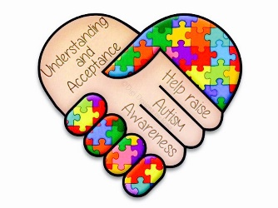

Welcome Back, Families!! This is an exciting time for you and your child as well as for us. Below are a few things your child will need to begin the school year.

|  |  |
| --- | --- |
| * A complete change of seasonally appropriate clothing including socks and underwear in a Ziploc bag with your child’s name labeled on the items. * 3 packs of baby wipes- if your child wears pull-ups please send in a pack of wipes **monthly****.** * Diapers or Pullups if needed. * 3 Plastic Two Pocket Folder * 2 package of sheet protectors * 2 Bottles of Liquid Antibacterial Soap * 3 boxes of Kleenex tissues * 3 Clorox Disinfection Wipes, pop up drum of 35 * 2- 1 Inch Binders * 16 Elmer’s Glue Sticks * 1 box of 24 Crayola Crayons * 2 packs of index cards 3’5 | * 2 packs of Ticonderoga pencils (sharpened) * 1 box of Crayola markers * 1 Pack of Dry Erase Markers * 1 rectangular plastic pencil box. * 1 pack of highlighters * 1 set of computer headphones * $10.00 cash for monthly individual scholastic magazine subscription and sight word journal * Labeled Photos of family members. * 1 pack of Therapy Putty (found on Amazon) This putty can last for years and will be moved with your child to the next grade. * 1 pack of playdough - (Play-Doh brand) |

* Each afternoon the class will have snack time. Due to specific allergies that students may have we are asking that parents provide a snack and drink for your child daily.
* The plastic two-pocket folder will be our child’s communication folder. The folder will be sent home daily. Please review the contents of the folder daily and keep any completed papers or notes and return the folder back to school the following day.
* Phone numbers must be kept up to date in case of an emergency. We **MUST** be able to reach you when needed. Therefore, please fill out the 3 emergency cards provided and return them as soon as possible.
* We hope to see your child every day, but in case of an absence for any reason, please send in a note to school the day your child returns stating why the child was absent. **Also, if your child needs to go home in a different manner than usual (ex: He will be picked up instead of riding the bus or getting picked up early) you MUST send in a note.**
* Most messages will be posted on ClassDojo app.

Thank You,

Mrs. Curry